**WEEK-5  
6. WebApi_Handson**

**Kafka Integration with C#:**

**Hands On:**

1. Create a Chat Application which uses Kafka as a streaming platform and consume the chat messages in the command prompt.

Output:

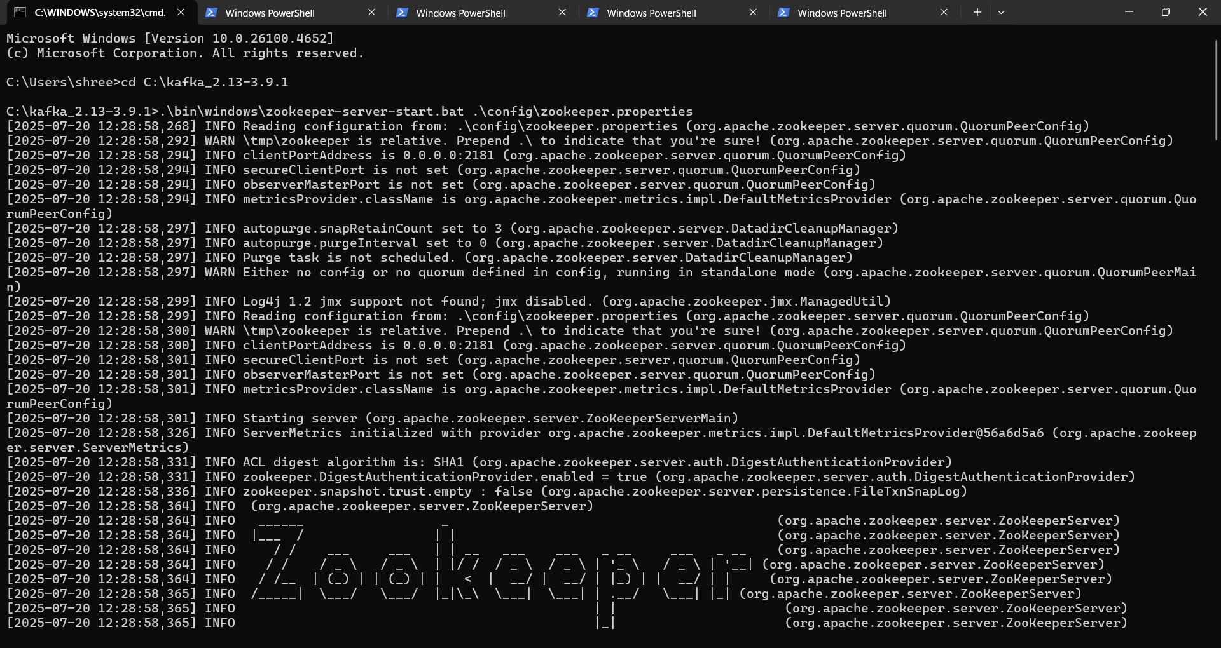

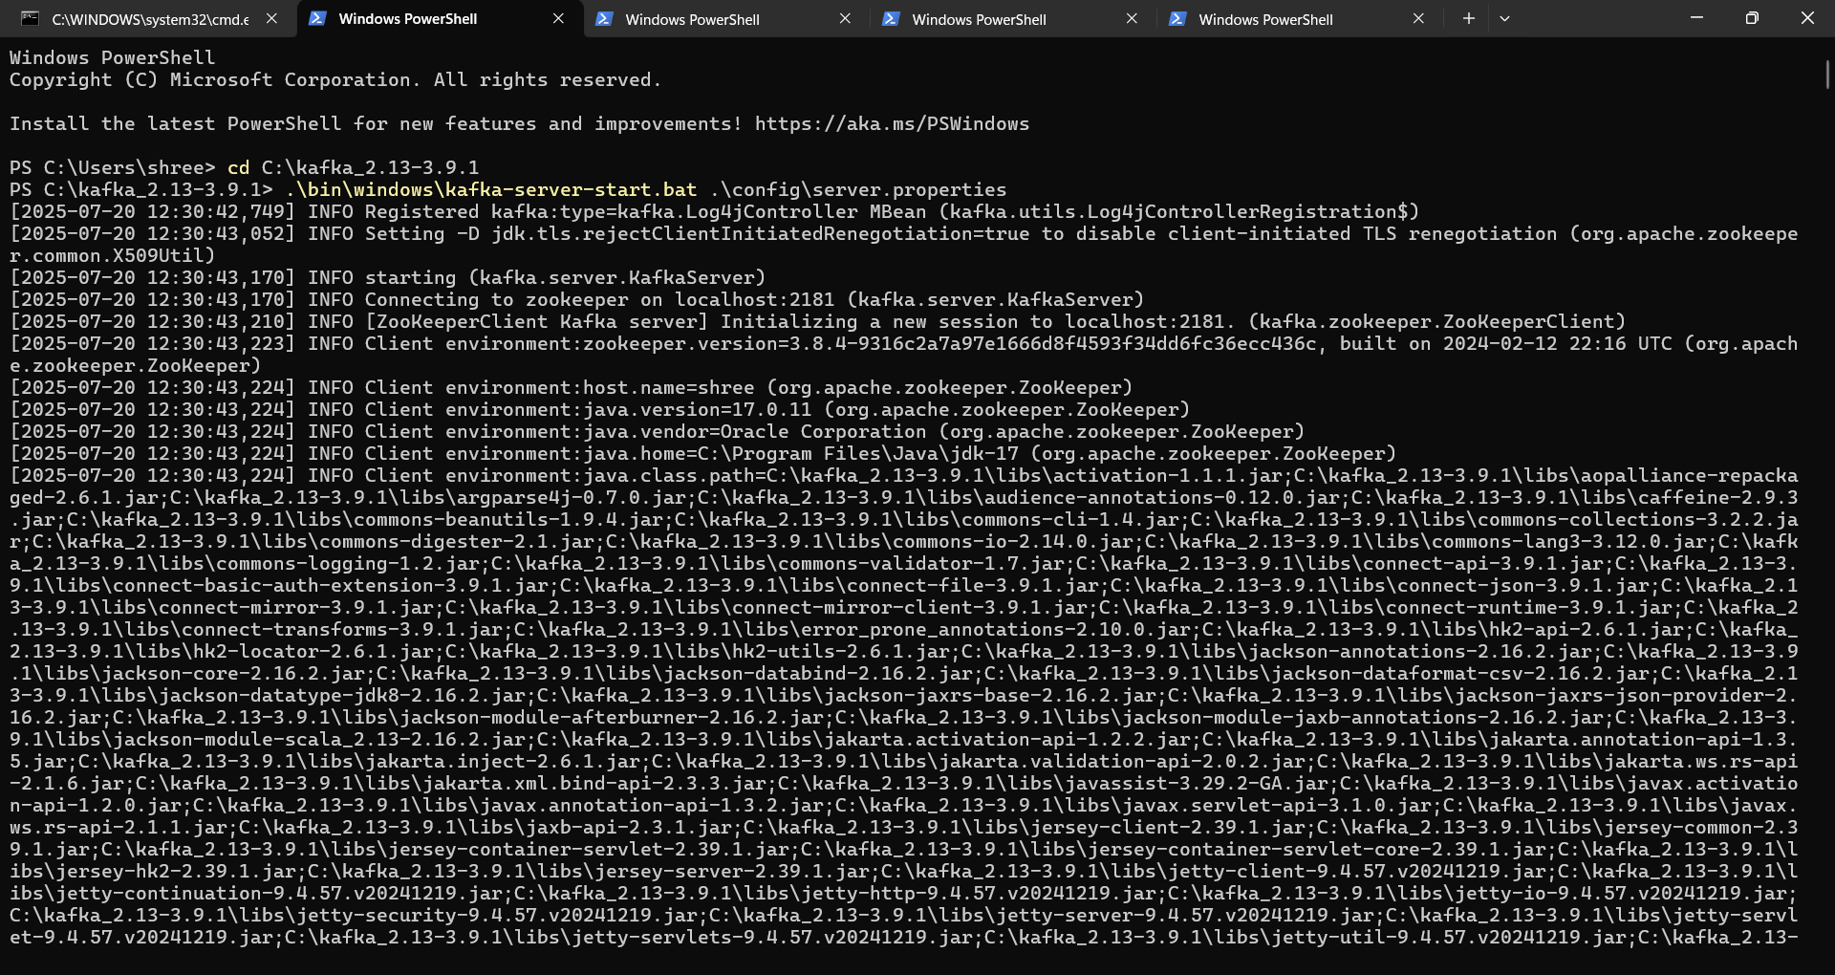

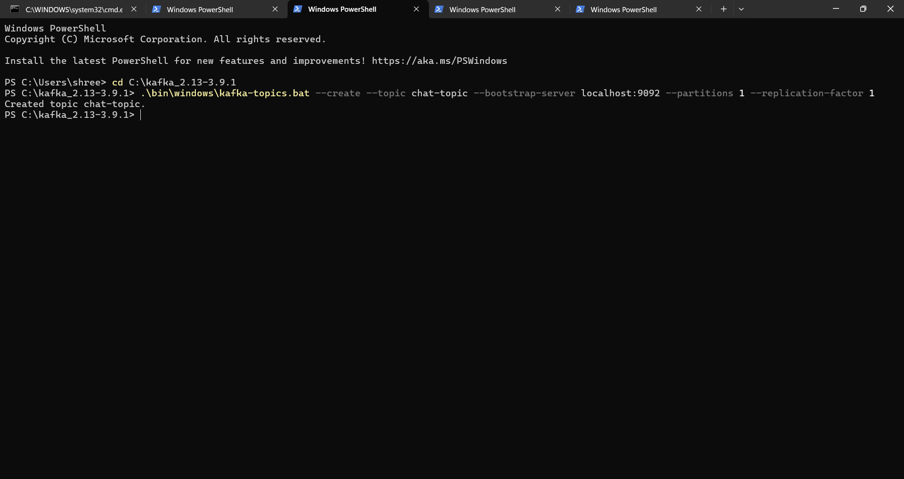

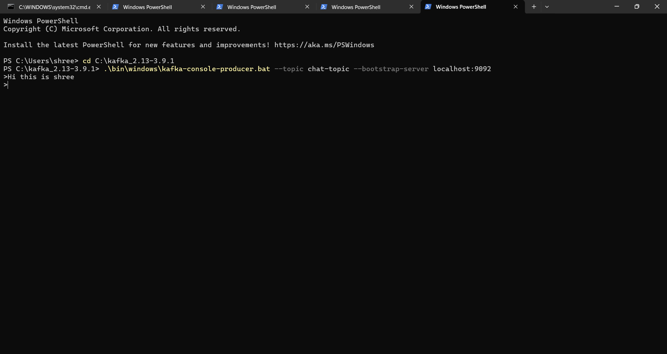

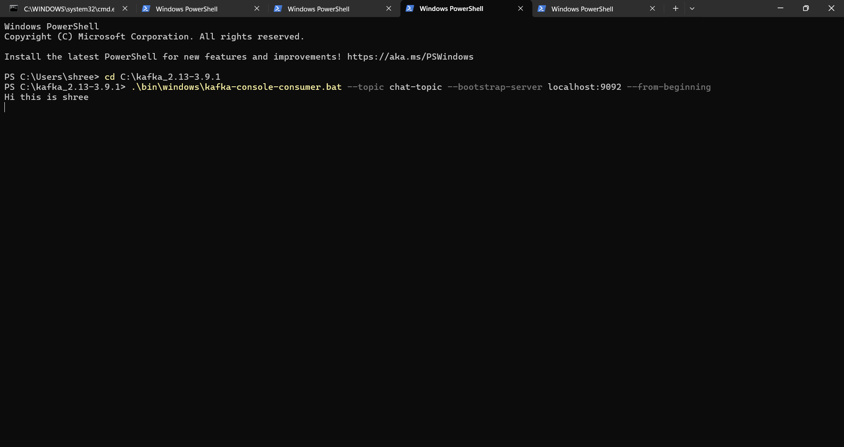

2.Create a Chat Application using C# Windows Application using Kafka and consume the message in different client applications.

Output:

